FYP2 design evolution. This document covers the sequence diagrams for UC1–UC36. UC34, UC35 and UC36 (§4.2.34–§4.2.36 at the end of the document) are FYP2 additions that capture the FYP1 pass-tracking, final-report grading and cycle-lifecycle flows, none of which existed in the FYP1 baseline. The existing UC1, UC14 and UC30 diagrams have also been extended with new alt branches to cover pre-approved roster auto-activation, login throttling, account-status guards, browser-push opt-in and pending-registration approval. Every FYP2 addition is highlighted with <mark> blocks and inline %% NEW (FYP2) comments inside the mermaid source. Implementation detail for each addition is documented in Chapter 5.

4.2.1 UC1 Register and Log In (All Roles)
FYP2 update: added pre-approved roster lookup (UC1 A5) and login-throttle lockout (UC1 A6) as new alt branches; account-status guard (UC1 E4) now also runs on every authenticated request.
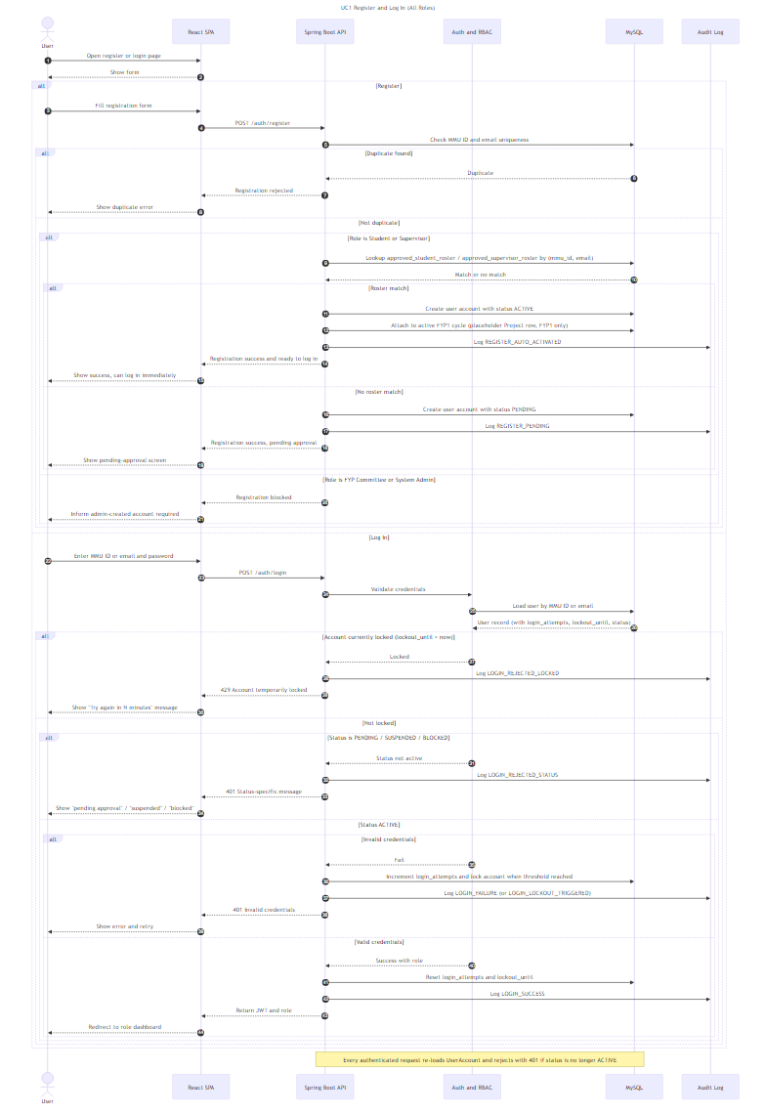

4.2.2 UC2 Manage Student Profile (Student)

Mermaid Sequence Diagram (UC2)
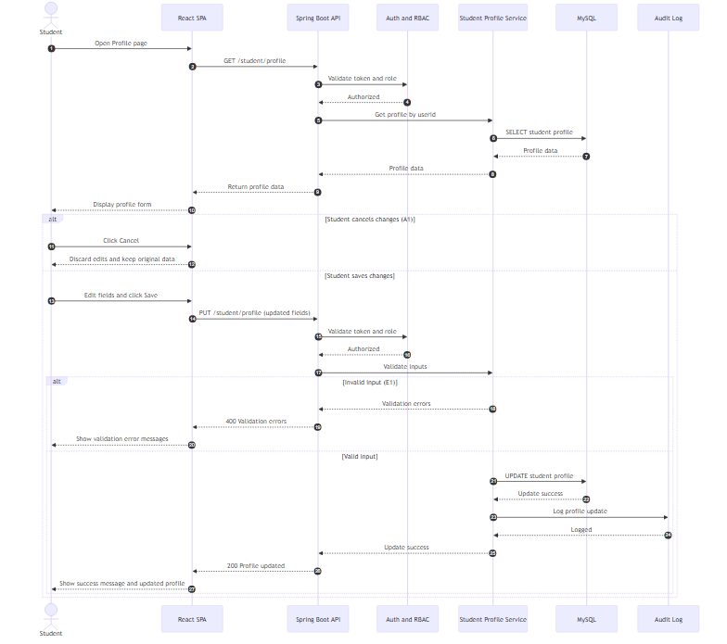

Report Section (Numbered Description)

4.2.2 UC2 Manage Student Profile (Student) — Figure 4.12
{insert diagram}
- The student opens the Profile page in the React SPA.
- The frontend requests the current profile using GET /student/profile.
- The backend verifies the student session using Auth and RBAC.
- The Student Profile Service retrieves profile data from MySQL and returns it to the frontend for display.
- The student edits the required profile fields (personal and academic details).
- If the student selects Cancel (A1), the system discards the changes and restores the previously loaded profile values.
- If the student selects Save, the frontend submits the updates using PUT /student/profile.
- The backend performs authentication and input validation.
- If validation fails (E1), the system returns error messages and the frontend displays the validation errors.
- If validation succeeds, the system updates the profile in MySQL, records the action in the Audit Log, and returns a success response.
- The frontend displays a success message and shows the updated profile information. ## 4.2.3 UC3 View FYP Dashboard (Student)

Mermaid Sequence Diagram (UC3)
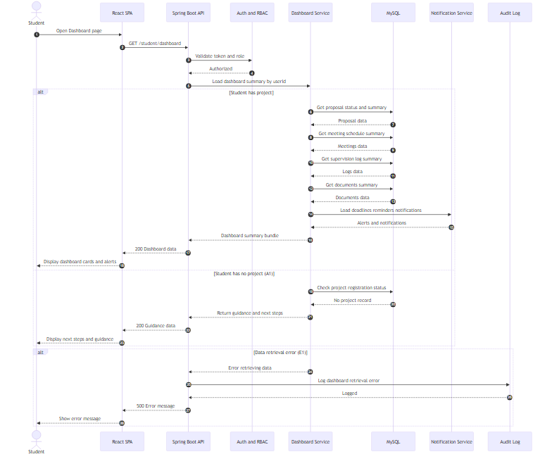
If your Mermaid tool is strict and fails when alt is placed after earlier alt, tell me — I’ll rewrite it into a single alt structure. (Some renderers are picky.)

Report Section (Numbered Description)

4.2.3 UC3 View FYP Dashboard (Student) — Figure 4.13
{insert diagram}
- The student opens the Dashboard page in the React SPA.
- The frontend sends GET /student/dashboard to the Spring Boot API.
- The backend validates the student session using Auth and RBAC.
- The Dashboard Service loads the dashboard summary for the student, including proposal status, meeting schedule, supervision logs, document summary, deadlines, and notifications.
- If the student has an active project, the system returns the summary data and the frontend displays dashboard cards and alerts.
- If the student has no project (A1), the system returns guidance and next steps (e.g., registration/proposal actions) and the frontend displays the guidance.
- If a data retrieval error occurs (E1), the system logs the error in the audit log and displays an error message to the student. ## 4.2.4 UC4 Browse and Search Supervisors (Student)
Figure 4.14 UC4 Browse and Search Supervisors Sequence Diagram

Mermaid code
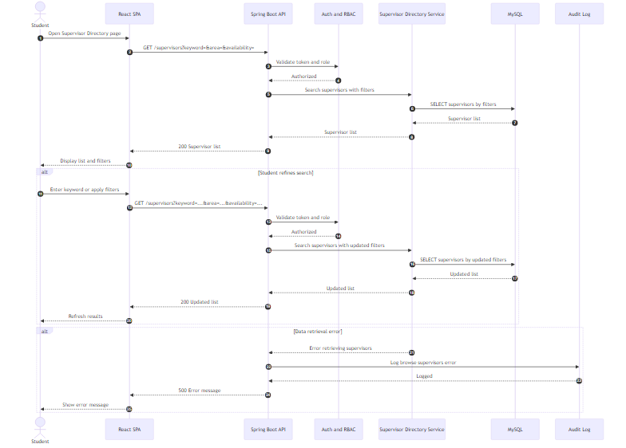

Report (numbered)
- Student opens the Supervisor Directory page.
- Frontend requests supervisors with optional filters via GET /supervisors.
- Backend validates the session using Auth and RBAC.
- Supervisor Directory Service queries MySQL and returns the supervisor list.
- Frontend displays the list and filter controls.
- If the student refines the search, the frontend sends another GET /supervisors with updated filters and refreshes results.
- If retrieval fails, the backend logs the error and the UI shows an error message.

4.2.5 UC5 View AI Supervisor Recommendations (Student)
FYP2 update: added quota/availability filtering step (UC5 A2) before recommendations are returned.
Figure 4.15 UC5 View AI Supervisor Recommendations Sequence Diagram

Mermaid code
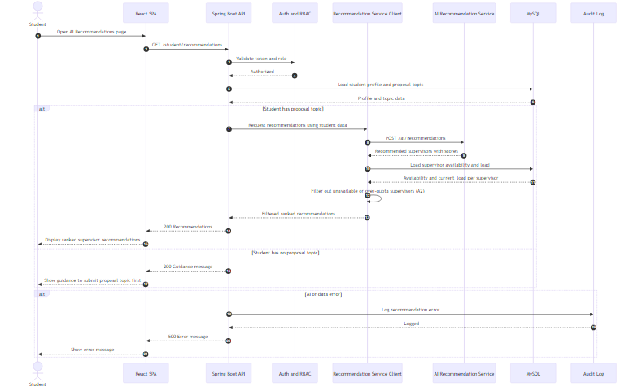

Report (numbered)
- Student opens the AI Recommendations page.
- Frontend calls GET /student/recommendations.
- Backend validates the session using Auth and RBAC.
- Backend loads the student profile and proposal topic from MySQL.
- If a proposal topic exists, backend calls the AI recommendation service and receives ranked supervisors with scores.
6. Recommendation Service Client loads each candidate supervisor’s availability_status and current_load vs supervision_quota and removes unavailable or over-quota supervisors before returning the ranked list (A2).
- Frontend displays the recommended supervisors.
- If no proposal topic exists, the system shows guidance to submit a proposal/topic first.
- If errors occur, the system logs the failure and displays an error message.

4.2.6 UC6 Send Supervisor Request (Student)
Figure 4.16 UC6 Send Supervisor Request Sequence Diagram

Mermaid code
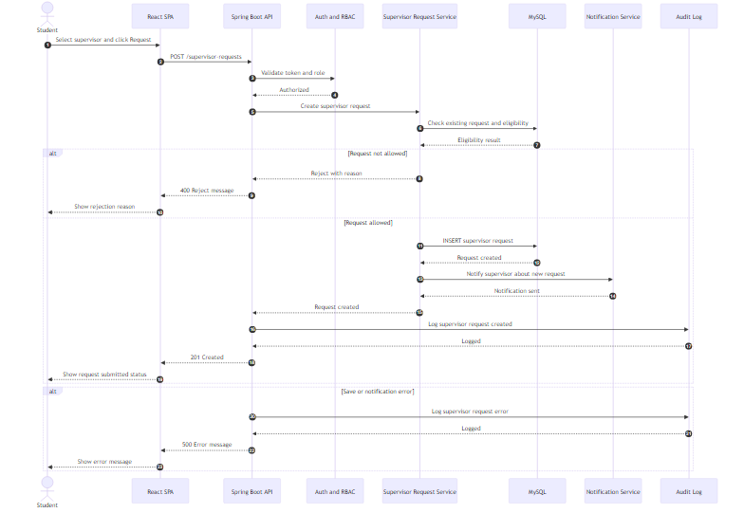

Report (numbered)
- Student selects a supervisor and submits a request.
- Frontend sends POST /supervisor-requests to the backend.
- Backend validates the student session via Auth and RBAC.
- Supervisor Request Service checks eligibility and whether a request already exists in MySQL.
- If not allowed, the system returns a rejection reason to the student.
- If allowed, the request is saved in MySQL and a notification is sent to the supervisor.
- The action is logged in the audit log and the UI shows the submitted status.
- If any error occurs, the system logs it and shows an error message.

4.2.7 UC7 Manage Proposal (Student)
FYP2 update: added on-demand AI checker that can run at proposal level (not only on submit) — backs UC7 A5 and the proposal-level link in PROPOSAL_CHECK_RESULT.proposal_id.
Figure 4.17 UC7 Manage Proposal Sequence Diagram

Mermaid code
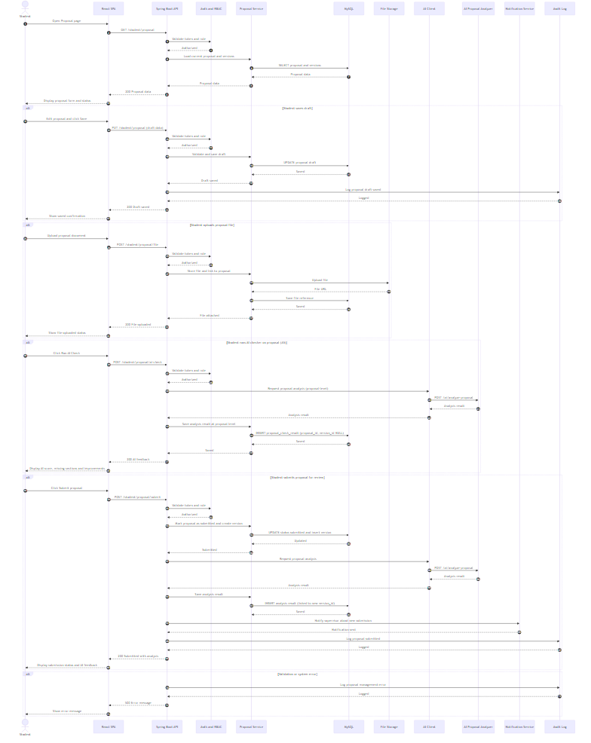

Report (numbered)
- Student opens the Proposal page; frontend requests current proposal via GET /student/proposal.
- Backend validates session via Auth and RBAC and loads proposal data from MySQL.
- The proposal form and current status are displayed to the student.
- If the student saves a draft, the frontend sends PUT /student/proposal; the backend validates and updates the draft record in MySQL, then logs the action.
- If the student uploads a proposal file, the frontend sends POST /student/proposal/file; the system stores the file in File Storage and saves its reference in MySQL.
6. If the student runs the AI checker on demand (A5), the backend calls the AI Proposal Analyzer and stores the result in proposal_check_result at the proposal level (proposal_id set, version_id left null), so the AI feedback is available without having to submit a new version.
- If the student submits the proposal, the backend updates the proposal status to submitted, creates a new version, and triggers the AI Proposal Analyzer.
- The AI analysis result is saved and returned to the student, and the supervisor is notified about the submission.
- Any validation or system error is logged and an error message is shown to the student.

If your draw.io Mermaid renderer complains about multiple alt blocks in UC7, tell me and I’ll rewrite UC7 into one single alt structure (some versions are picky). ## 4.2.8 UC8 View Proposal Status (Student)
FYP2 update: the timeline now includes AI proposal-checker results alongside review history.
Figure 4.18 UC8 View Proposal Status Sequence Diagram

Mermaid
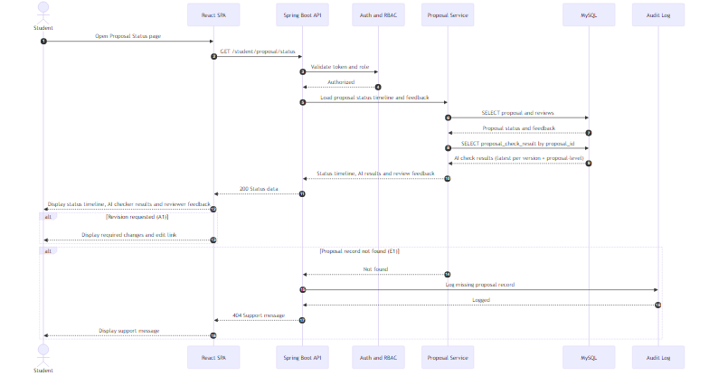

Report (numbered)
- Student opens the Proposal Status page.
- Frontend sends GET /student/proposal/status to the backend.
- Backend validates the session using Auth and RBAC.
- Proposal Service retrieves proposal status timeline and supervisor feedback from MySQL and additionally loads AI checker results from proposal_check_result (both version-level and proposal-level entries).
- System returns the status data and the frontend displays the timeline, AI checker results, and feedback.
- If revision is requested (A1), the system highlights required changes and provides an edit link.
- If no proposal record exists (E1), the system logs the issue and displays a support message.

4.2.9 UC9 View Project Registration Status (Student)
Figure 4.19 UC9 View Project Registration Status Sequence Diagram

Mermaid
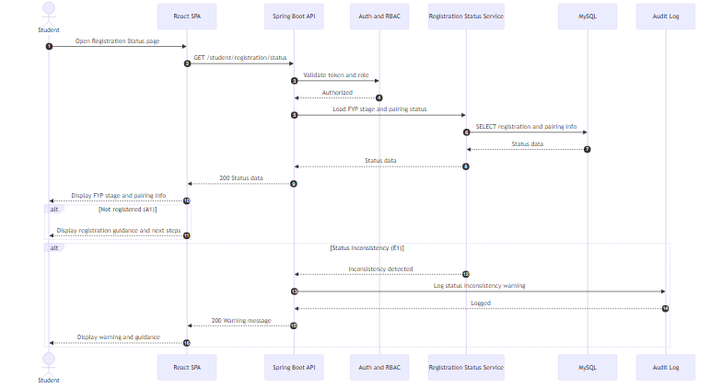

Report (numbered)
- Student opens Registration Status page.
- Frontend calls GET /student/registration/status.
- Backend validates the session using Auth and RBAC.
- Registration Status Service loads FYP stage and pairing status from MySQL.
- Frontend displays the current stage, pairing information, and next steps.
- If the student is not registered (A1), the system shows registration guidance.
- If an inconsistency is detected (E1), the system shows a warning and logs the issue.

4.2.10 UC10 Manage Meeting Schedule (Student)
Figure 4.20 UC10 Manage Meeting Schedule Sequence Diagram

Mermaid
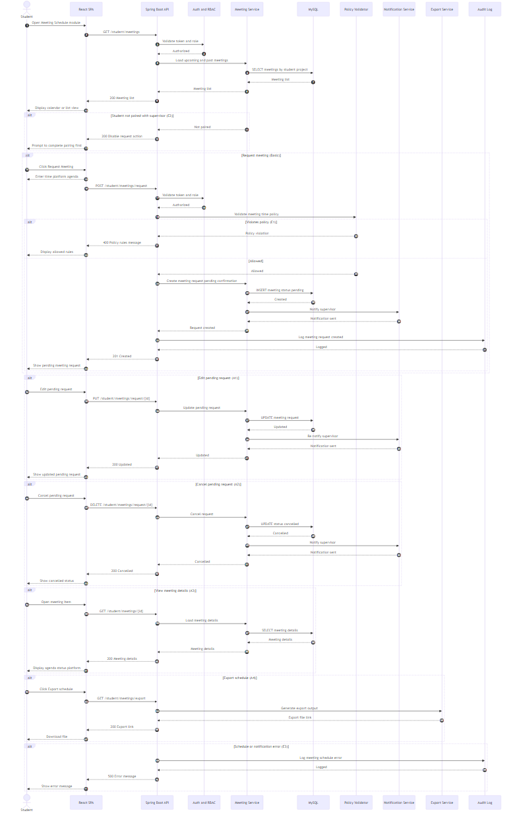

Report (numbered)
- Student opens Meeting Schedule module.
- Frontend requests meeting list via GET /student/meetings.
- Backend validates session and returns upcoming and past meetings from MySQL.
- If student is not paired (E2), the request action is disabled and guidance is shown.
- Student can request a meeting by submitting time, platform, and agenda.
- System validates policy rules; if violated (E1), it blocks submission and shows allowed rules.
- If allowed, system creates a pending request, notifies the supervisor, and shows pending status.
- Student may edit (A1) or cancel (A2) a pending request; system updates status and notifies supervisor.
- Student can view details (A3) and export schedule (A4).
- Any service error (E3) is logged and an error message is displayed.

4.2.11 UC11 Manage Supervision Log (Student)
Figure 4.21 UC11 Manage Supervision Log Sequence Diagram

Mermaid
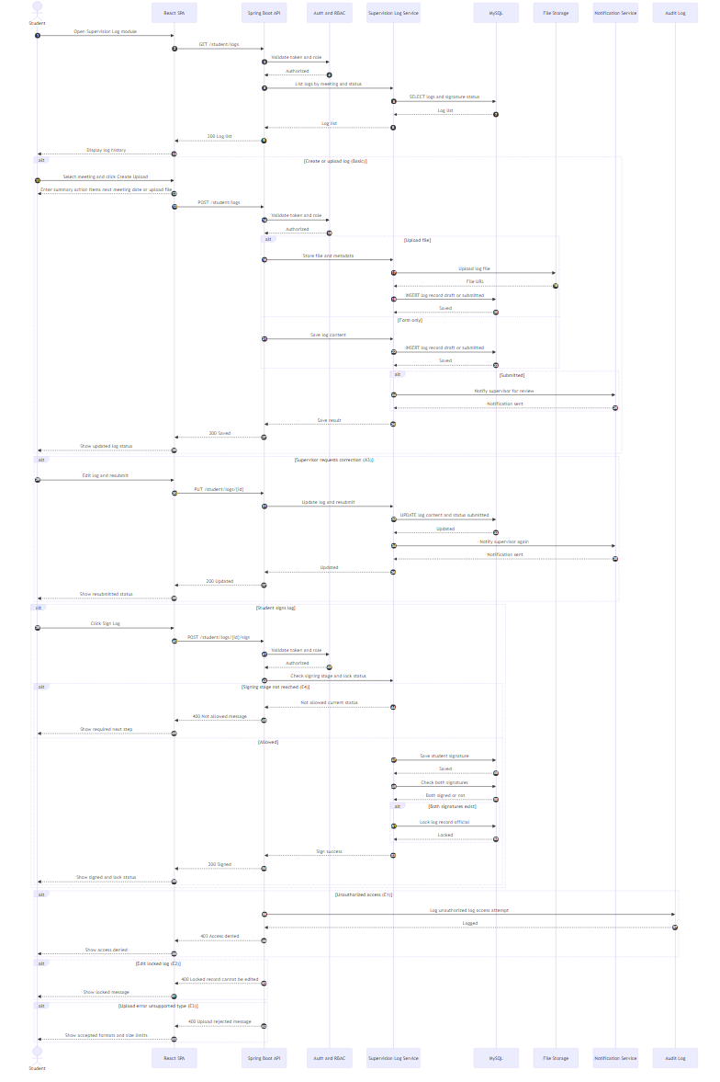

Report (numbered)
- Student opens Supervision Log module; system lists logs by meeting with status and signatures.
- Student creates or uploads a log; system stores content and optional file, then saves to MySQL and File Storage.
- If submitted, the supervisor is notified for review.
- If correction is requested (A3), student edits and re-submits and the supervisor is notified again.
- When signing is allowed, student signs the log; the system records the signature and locks the log if both signatures exist.
- Unauthorized access, locked-edit attempts, upload errors, or signing too early trigger the relevant error messages and logging.

4.2.12 UC12 Upload and Manage FYP Documents (Student)
Figure 4.22 UC12 Upload and Manage FYP Documents Sequence Diagram

Mermaid
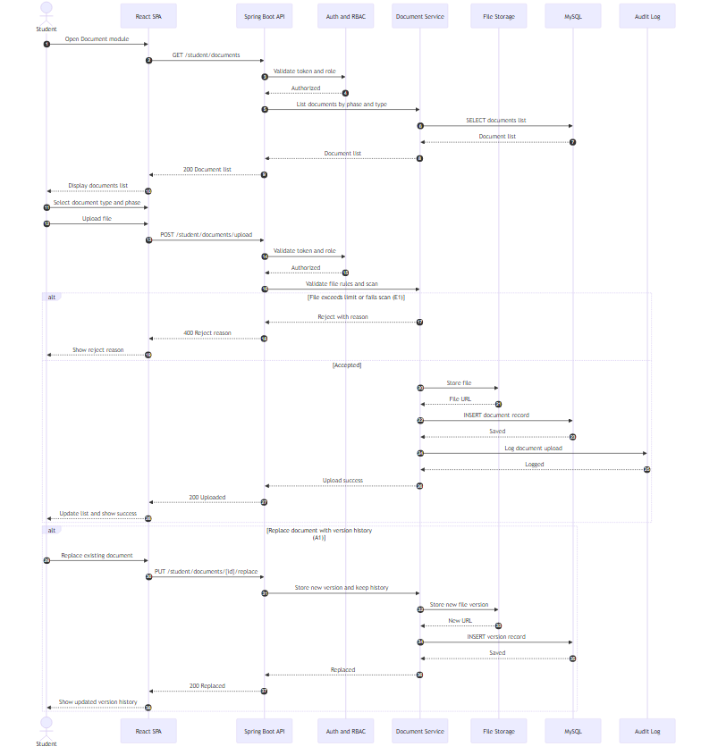

Report (numbered)
- Student opens Document module and the system lists existing documents.
- Student selects document phase and type, then uploads a file.
- Backend validates session and checks file constraints and scanning rules.
- If file fails (E1), the system rejects and shows the reason.
- If accepted, the file is stored in File Storage and metadata is saved in MySQL.
- If replacing a document (A1), the system stores a new version and keeps version history.

4.2.13 UC13 View FYP Guidelines, Rubrics and Deadlines (Student)
Figure 4.23 UC13 View FYP Guidelines, Rubrics and Deadlines Sequence Diagram

Mermaid
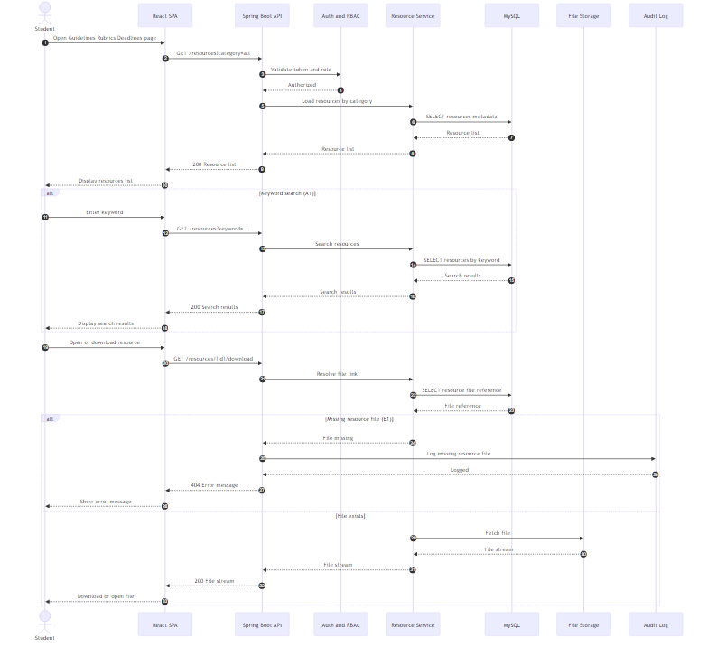

Report (numbered)
- Student opens Guidelines, Rubrics and Deadlines page.
- System loads resources by category and displays them.
- Student may search by keyword (A1); system returns matching resources.
- Student opens or downloads a resource; system retrieves the file from storage.
- If the file is missing (E1), the system logs the incident and shows an error message.

4.2.14 UC14 View Reminders and Notifications (Student)
FYP2 update: notifications are now filtered by per-user preferences (user_notification_preferences) before delivery and dispatched to the configured channels (in-app inbox, email, and browser push (UC14 A2) via VAPID-signed payloads).
Figure 4.24 UC14 View Reminders and Notifications Sequence Diagram

Mermaid
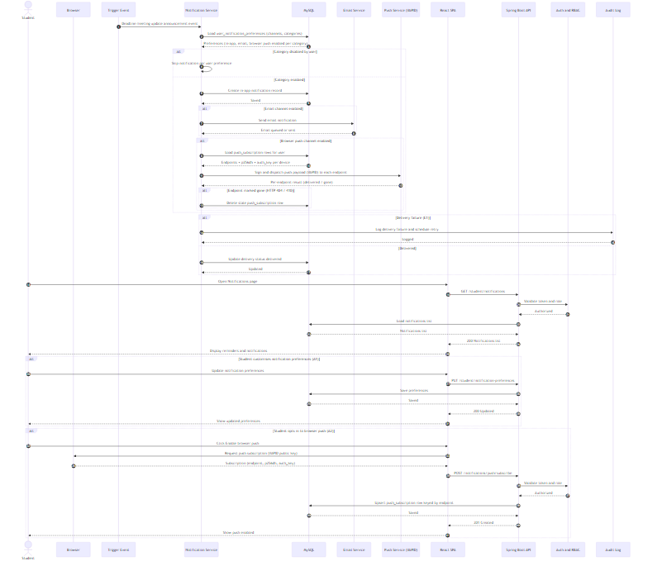

Report (numbered)
- A trigger event occurs (deadline, meeting update, or announcement).
2. Notification Service loads the recipient’s user_notification_preferences and skips delivery if the category is disabled.
3. If the category is enabled, an in-app notification record is created; if the email channel is also enabled in preferences, the email service is invoked in addition.
- If delivery fails (E1), the system logs the failure and retries based on rules; otherwise delivery status is updated.
- Student opens the Notifications page; system retrieves and displays notifications.
- Student may update notification preferences (A1); the system saves the updated preferences.

4.2.15 UC15 Ask Questions Using the FYP Chatbot (Student)
Figure 4.25 UC15 Ask Questions Using the FYP Chatbot Sequence Diagram

Mermaid
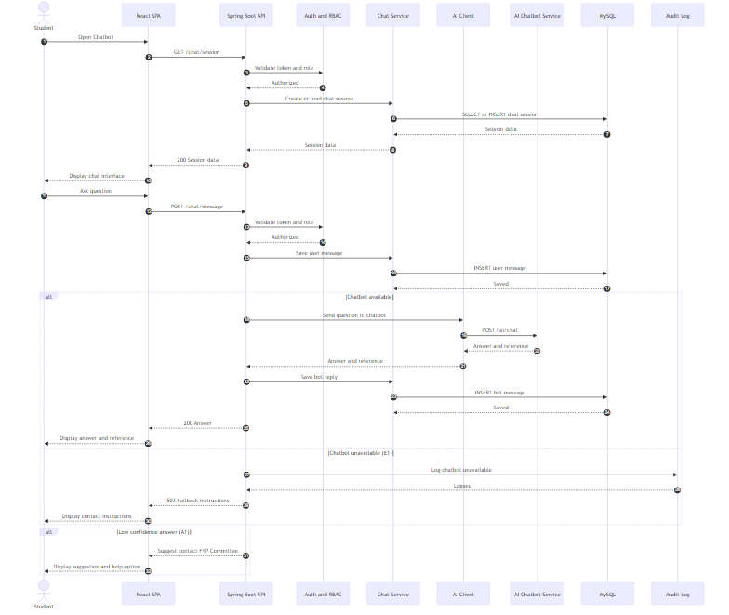

Report (numbered)
- Student opens the chatbot; system creates or loads a chat session.
- Student sends a question; the system stores the user message.
- If chatbot service is available, the backend sends the query to the AI chatbot and returns an answer with references, then stores the bot reply.
- If chatbot is unavailable (E1), the system logs the issue and shows fallback contact instructions.
- If the response confidence is low (A1), the system suggests contacting the FYP Committee and provides a help option.

4.2.16 UC16 Manage Supervisor Profile (Supervisor)
Figure 4.26 UC16 Manage Supervisor Profile Sequence Diagram

Mermaid
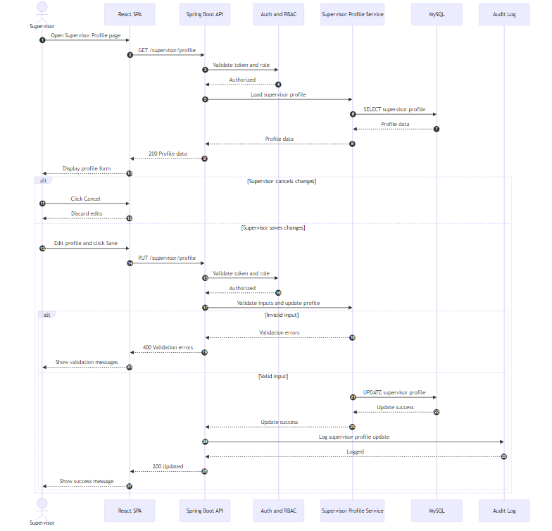

Report (numbered)
- Supervisor opens Profile page; frontend requests current profile.
- Backend validates session and loads supervisor profile from MySQL.
- Supervisor edits profile fields (research areas, quota, availability) or cancels.
- On save, backend validates input and updates the profile in MySQL.
- If validation fails, error messages are shown; otherwise success is returned and logged.

4.2.17 UC17 Review and Respond to Supervisor Requests (Supervisor)
Figure 4.27 UC17 Review and Respond to Supervisor Requests Sequence Diagram

Mermaid
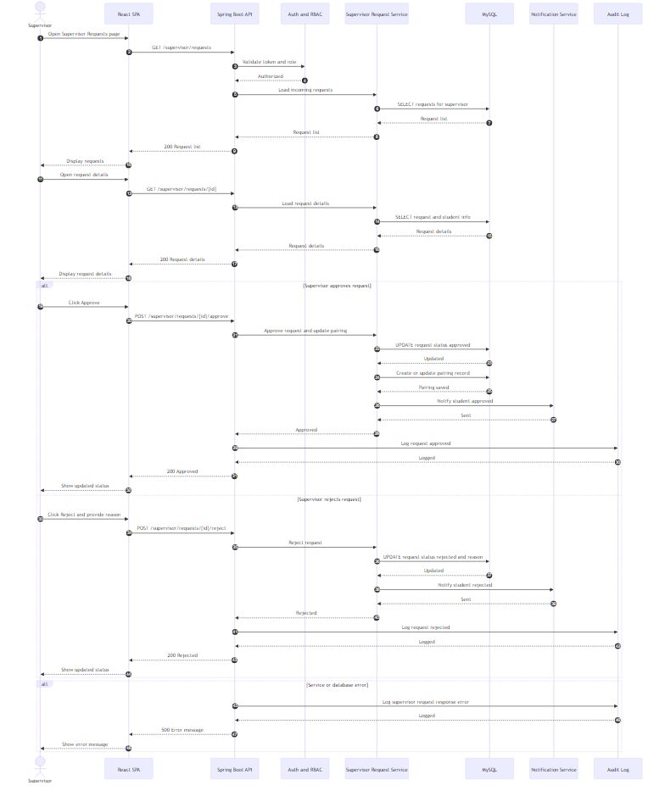

Report (numbered)
- Supervisor opens Requests module; system loads incoming requests.
- Supervisor views a request and chooses approve or reject.
- On approve, the system updates request status, creates pairing, notifies student, and logs the action.
- On reject, the system updates status with reason, notifies student, and logs the action.
- Errors are logged and shown to the supervisor.

4.2.18 UC18 View Supervisee List and Project Details (Supervisor)
Figure 4.28 UC18 View Supervisee List and Project Details Sequence Diagram

Mermaid
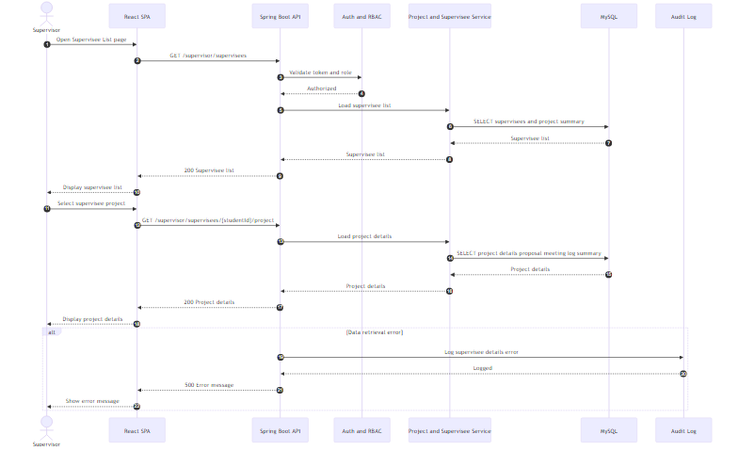

Report (numbered)
- Supervisor opens Supervisee List; system loads supervisee projects.
- Supervisor selects a supervisee; system loads detailed project information from MySQL.
- Frontend displays supervisee list and selected project details.
- Any retrieval error is logged and displayed.

4.2.19 UC19 Review Student Proposal (Supervisor)
Figure 4.29 UC19 Review Student Proposal Sequence Diagram

Mermaid
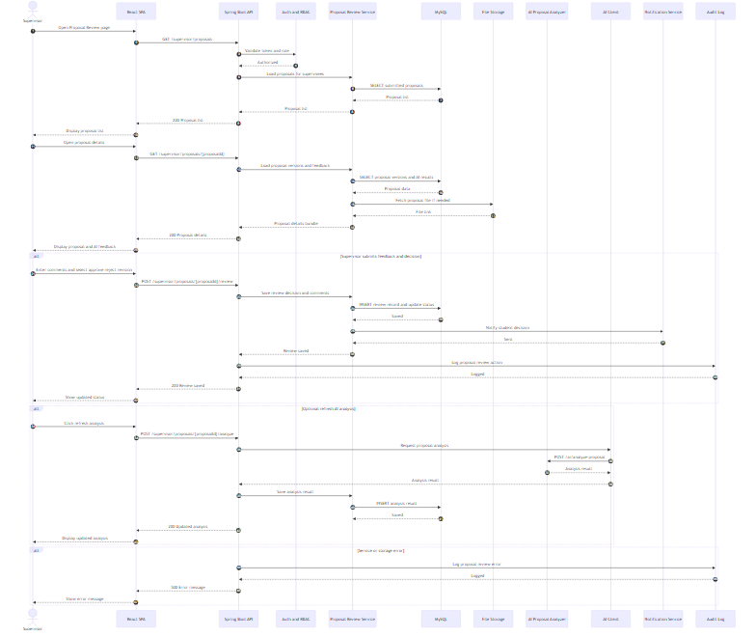

Report (numbered)
- Supervisor opens Proposal Review and loads submitted proposals.
- Supervisor opens a proposal; system loads versions, files, and AI results.
- Supervisor enters comments and submits decision; system updates status, stores feedback, notifies student, and logs the action.
- Supervisor may refresh AI analysis; system calls AI service and stores updated results.
- Errors are logged and shown.

4.2.20 UC20 Manage Supervision Meetings (Supervisor)
Figure 4.30 UC20 Manage Supervision Meetings Sequence Diagram

Mermaid
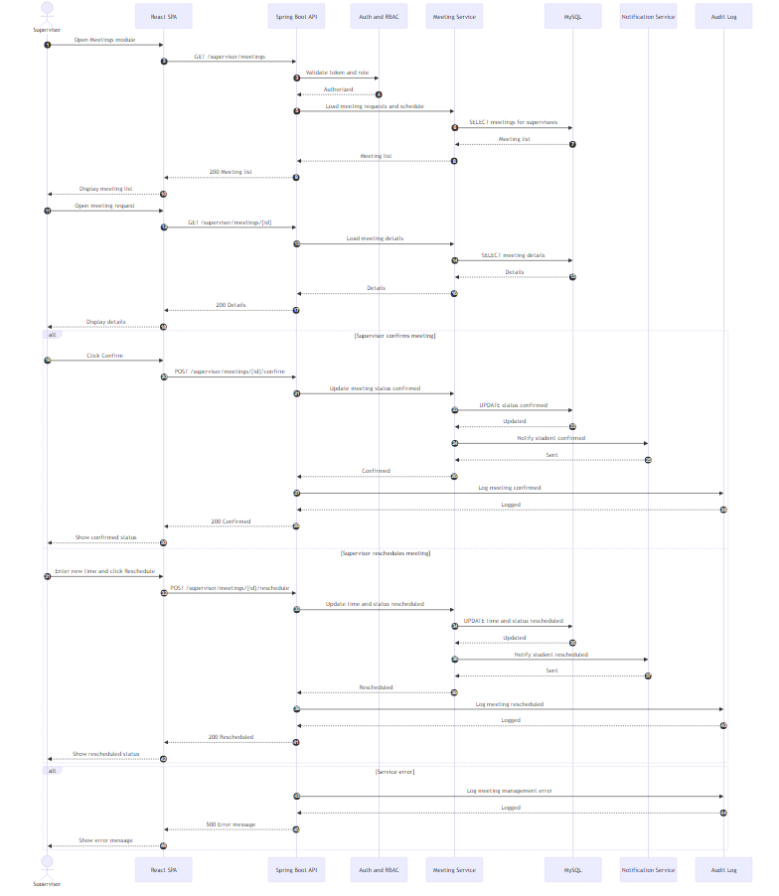

Report (numbered)
- Supervisor opens Meetings module and views meeting requests.
- Supervisor opens a request to view details.
- Supervisor confirms or reschedules; system updates the meeting record, notifies student, and logs the action.
- Errors are logged and shown.

4.2.21 UC21 Review, Comment on and Sign Supervision Log (Supervisor)
Figure 4.31 UC21 Review, Comment on and Sign Supervision Log Sequence Diagram

Mermaid
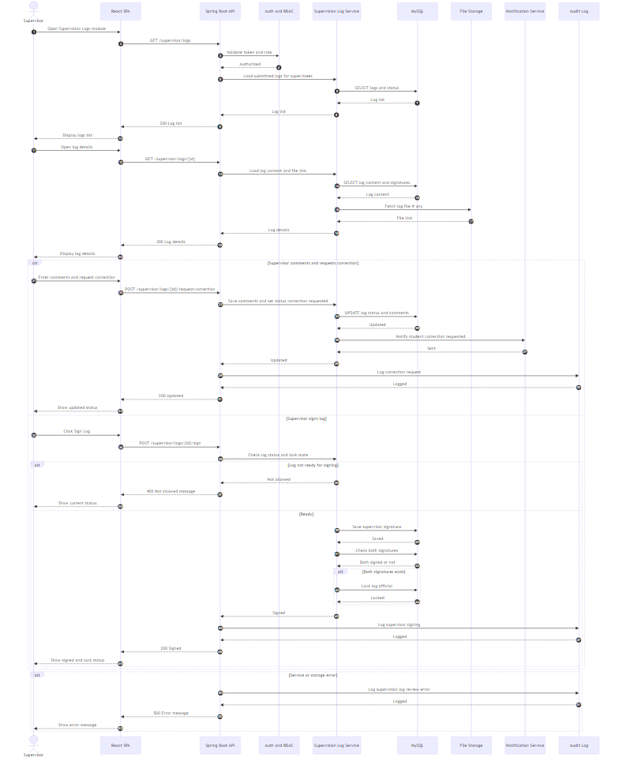

Report (numbered)
- Supervisor opens Logs module and views submitted logs.
- Supervisor opens a log and reviews content and attachments.
- Supervisor may request correction with comments; system updates status and notifies student.
- Supervisor may sign the log; system records the signature and locks the log when both signatures exist.
- Errors are logged and shown.

4.2.22 UC22 View Supervisee Progress Dashboard (Supervisor)
FYP2 update: dashboard now aggregates explicit per-supervisee indicators (proposal status, meeting count, log compliance, document submission state, deadlines) and flags at-risk supervisees.
Figure 4.32 UC22 View Supervisee Progress Dashboard Sequence Diagram

Mermaid
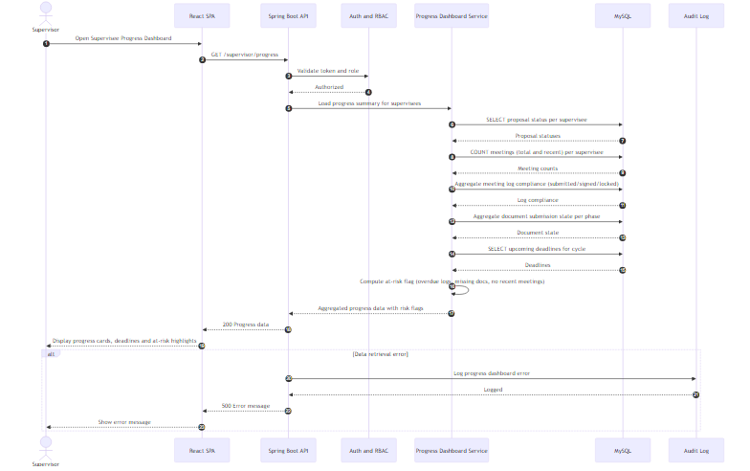

Report (numbered)
- Supervisor opens Progress Dashboard.
2. Progress Dashboard Service loads, per supervisee, the proposal status, total and recent meeting count, supervision-log compliance (submitted / signed / locked), document submission state per phase, and upcoming deadlines.
3. Service computes an at-risk flag for each supervisee based on overdue logs, missing documents and no recent meetings.
- Frontend displays progress cards, deadlines and at-risk highlights.
- Errors are logged and displayed.

4.2.23 UC23 Upload, Download and Review FYP Documents (Supervisor)
Figure 4.33 UC23 Upload, Download and Review FYP Documents Sequence Diagram

Mermaid
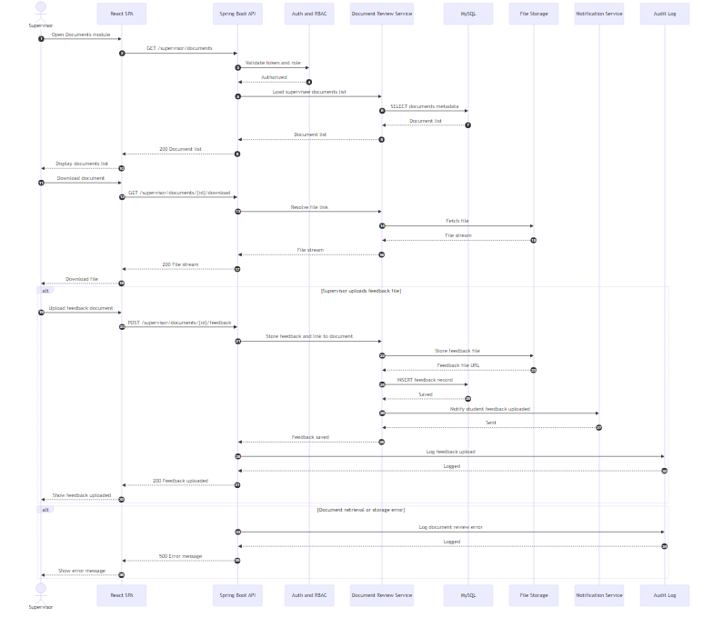

Report (numbered)
- Supervisor opens Documents module and loads supervisee document list.
- Supervisor downloads a document; the system retrieves the file from storage.
- Supervisor may upload feedback; the system stores the feedback file, records metadata, notifies the student, and logs the action.
- Errors are logged and displayed.

4.2.24 UC24 Publish FYP Announcements (Supervisor, FYP Committee)
Figure 4.34 UC24 Publish FYP Announcements Sequence Diagram

Mermaid
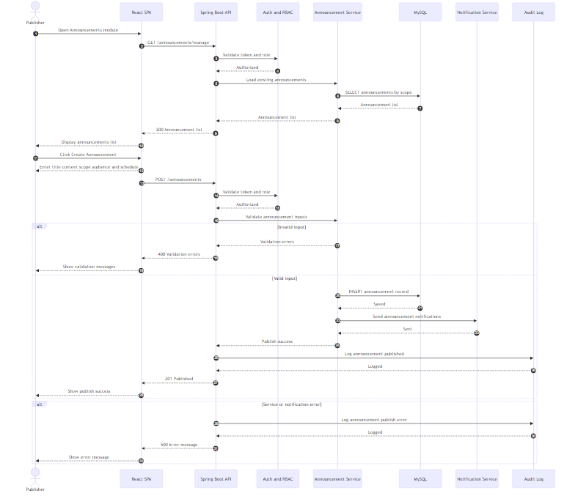

Report (numbered)
- Supervisor or FYP Committee opens the Announcements module.
- System loads existing announcements after validating access via Auth and RBAC.
- Publisher creates an announcement by entering title, content, scope, and target audience.
- System validates inputs; if invalid, validation messages are displayed.
- If valid, the announcement is stored in MySQL, notifications are sent, and the action is logged.
- Any error is logged and shown to the publisher.

4.2.25 UC25 View Proposal Review Queue (FYP Committee)
Figure 4.35 UC25 View Proposal Review Queue Sequence Diagram

Mermaid
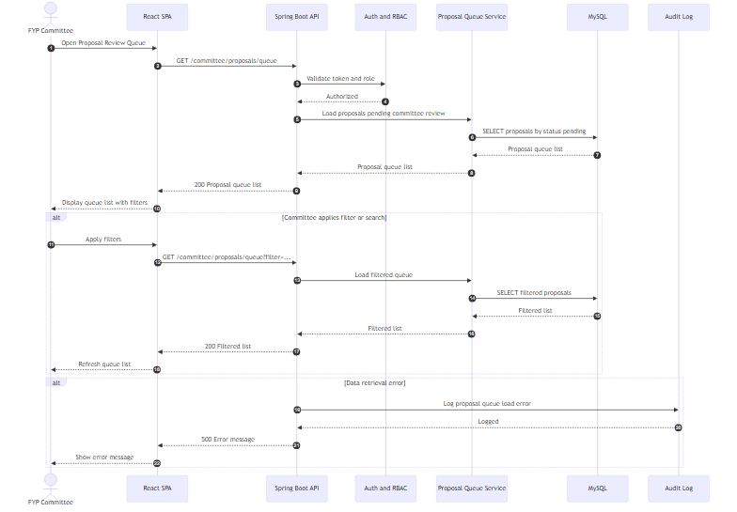

Report (numbered)
- FYP Committee opens the Proposal Review Queue.
- Backend validates the committee role and loads proposals pending review from MySQL.
- Frontend displays the queue and supports filtering/searching.
- Errors during retrieval are logged and shown.

4.2.26 UC26 Review Proposal (FYP Committee)
Figure 4.36 UC26 Review Proposal Sequence Diagram

Mermaid
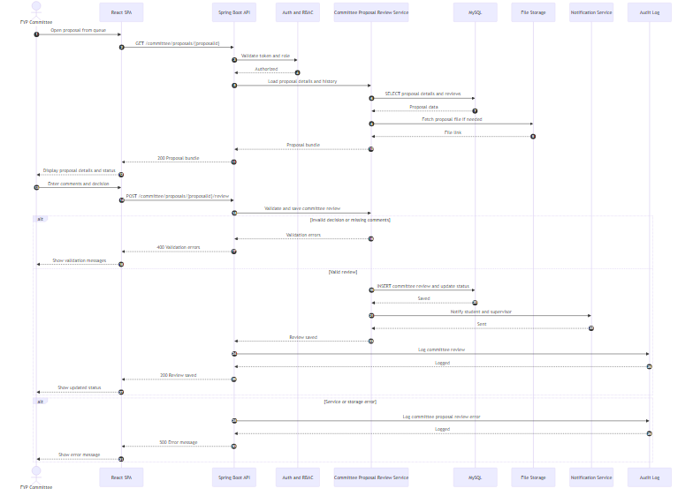

Report (numbered)
- Committee opens a proposal from the queue.
- System validates access and loads proposal details, history, and file link.
- Committee submits decision and comments.
- System validates the review; if valid, saves decision, updates status, notifies relevant users, and logs the action.
- Errors are logged and shown.

4.2.27 UC27 Manage General FYP Documents (FYP Committee)
Figure 4.37 UC27 Manage General FYP Documents Sequence Diagram

Mermaid
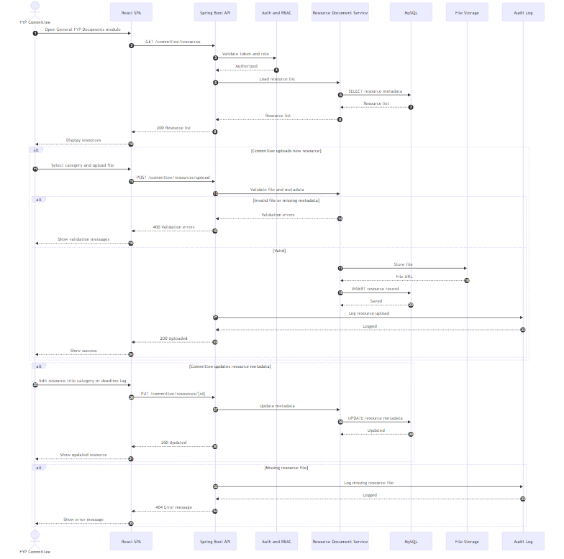

Report (numbered)
- Committee opens General FYP Documents and views existing resources.
- Committee may upload a new resource; system validates, stores file, saves metadata, and logs the action.
- Committee may update resource metadata; system updates records in MySQL.
- Missing file incidents are logged and shown.

4.2.28 UC28 View FYP Project and Pairing Overview (FYP Committee)
Figure 4.38 UC28 View FYP Project and Pairing Overview Sequence Diagram

Mermaid
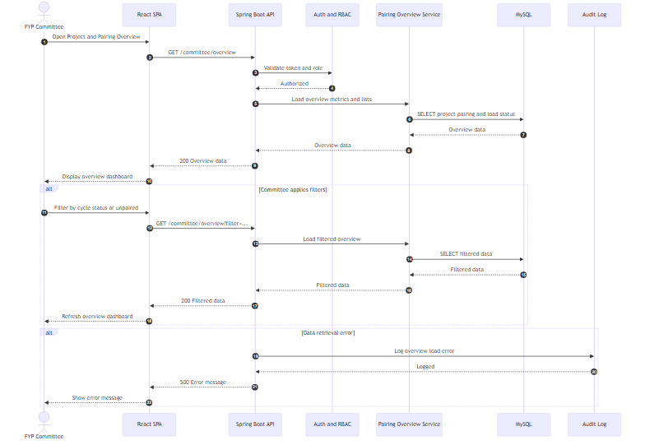

Report (numbered)
- Committee opens the Project and Pairing Overview page.
- System validates access and retrieves pairing, load, and project status metrics from MySQL.
- Committee can apply filters; system refreshes the displayed overview.
- Errors are logged and shown.

4.2.29 UC29 Generate and Export FYP Reports (FYP Committee)
FYP2 update: generated report metadata is now persisted in generated_report (type, title, filters, format, file path, generated-by user, expires_at) so committees can re-download from a report history list.
Figure 4.39 UC29 Generate and Export FYP Reports Sequence Diagram

Mermaid
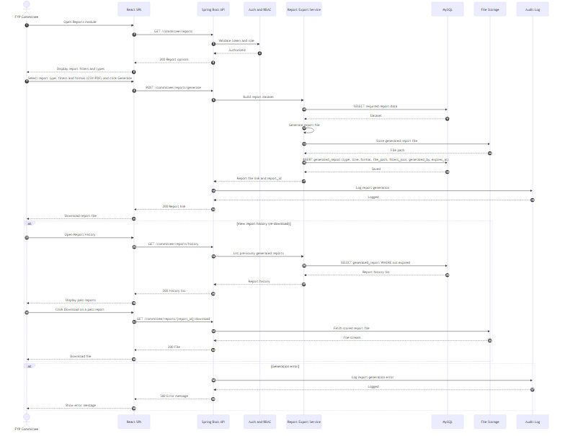

Report (numbered)
- Committee opens Reports module and views available report types and filters.
- Committee selects report type, filters and output format (CSV / PDF), then generates the report.
- Report service retrieves required data from MySQL, generates the report file, and stores it in File Storage.
4. Report metadata (type, title, filters, format, file path, generated-by user, expiry) is persisted in generated_report so the report can be re-downloaded later.
- System returns a downloadable link and logs the generation activity.
6. Committee can later open Report History to list previously generated reports and re-download any non-expired report directly from File Storage.
- Any generation error is logged and displayed.
## 4.2.30 UC30 Manage User Accounts and Roles (System Administrator)
FYP2 update: added bulk CSV import (UC30 A2) with row-level validation, pre-approved roster CSV upload (UC30 A3) and pending-registration approve/reject queue (UC30 A4).
Figure 4.40 UC30 Manage User Accounts and Roles Sequence Diagram
### Mermaid
```mermaid sequenceDiagram autonumber actor ADM as System Administrator participant FE as React SPA participant BE as Spring Boot API participant AUTH as Auth and RBAC participant UMS as User Account Service participant DB as MySQL participant NOTI as Notification Service participant AUD as Audit Log
ADM->>FE: Open User Management module FE->>BE: GET /admin/users BE->>AUTH: Validate token and admin role AUTH–>>BE: Authorized BE->>UMS: Load user accounts list UMS->>DB: SELECT users with roles and status DB–>>UMS: User list UMS–>>BE: User list BE–>>FE: 200 User list FE–>>ADM: Display users list and actions
alt Create user account ADM->>FE: Click Create User FE–>>ADM: Enter user details and role FE->>BE: POST /admin/users BE->>UMS: Validate and create account alt Invalid input or duplicate UMS–>>BE: Validation or duplicate error BE–>>FE: 400 Error message FE–>>ADM: Show validation message else Valid UMS->>DB: INSERT user account and role DB–>>UMS: Created UMS->>NOTI: Send account credentials or invite NOTI–>>UMS: Sent UMS–>>BE: Created BE->>AUD: Log user created AUD–>>BE: Logged BE–>>FE: 201 Created FE–>>ADM: Show success and refresh list end end
alt Update role or status ADM->>FE: Change role or activate deactivate FE->>BE: PUT /admin/users/{id} BE->>UMS: Validate update rules alt Invalid update UMS–>>BE: Update blocked message BE–>>FE: 400 Blocked FE–>>ADM: Show blocked reason else Valid update UMS->>DB: UPDATE role or status DB–>>UMS: Updated UMS–>>BE: Updated BE->>AUD: Log user updated AUD–>>BE: Logged BE–>>FE: 200 Updated FE–>>ADM: Show success end end
%% NEW (FYP2): bulk CSV import (A2) alt Bulk import users from CSV (A2) ADM->>FE: Upload CSV file (mmu_id, email, full_name, role) FE->>BE: POST /admin/users/import BE->>AUTH: Validate token and admin role AUTH–>>BE: Authorized BE->>UMS: Parse and validate CSV rows UMS->>DB: Check duplicates per row (mmu_id, email) DB–>>UMS: Duplicate check result per row UMS->>UMS: Build per-row success or error result loop Each valid row UMS->>DB: INSERT user_account DB–>>UMS: Created end UMS–>>BE: Import summary (created count, error rows) BE->>AUD: Log bulk user import AUD–>>BE: Logged BE–>>FE: 200 Import summary FE–>>ADM: Show created count and per-row errors end
%% NEW (FYP2 A3): pre-approved roster CSV upload alt Upload pre-approved roster CSV (A3) ADM->>FE: Upload student or supervisor roster CSV FE->>BE: POST /admin/roster/students/import or /admin/roster/supervisors/import BE->>AUTH: Validate token and admin role AUTH–>>BE: Authorized BE->>UMS: Parse and validate roster CSV (mmu_id, email, programme/department, …) UMS->>DB: Upsert into approved_student_roster or approved_supervisor_roster DB–>>UMS: Inserted / updated counts UMS–>>BE: Summary BE->>AUD: Log ROSTER_UPLOADED AUD–>>BE: Logged BE–>>FE: 200 Roster summary FE–>>ADM: Show added/updated counts Note over BE,DB: Future self-registrations matching a roster row will auto-activate as in UC1 A5 end
%% NEW (FYP2 A4): pending-registration approve/reject queue alt Review pending registrations (A4) ADM->>FE: Open Pending Registrations page FE->>BE: GET /admin/users/pending BE->>UMS: List PENDING accounts UMS->>DB: SELECT user_account WHERE status = ‘PENDING’ DB–>>UMS: Pending list UMS–>>BE: List BE–>>FE: 200 Pending list FE–>>ADM: Display pending registrations alt Admin clicks Approve ADM->>FE: Click Approve on a row FE->>BE: POST /admin/users/{id}/approve BE->>UMS: Set status ACTIVE UMS->>DB: UPDATE user_account.status = ‘ACTIVE’ DB–>>UMS: Updated UMS->>NOTI: Notify user of approval NOTI–>>UMS: Notified BE->>AUD: Log USER_APPROVED BE–>>FE: 200 OK FE–>>ADM: Refresh queue else Admin clicks Reject ADM->>FE: Click Reject and enter reason FE->>BE: POST /admin/users/{id}/reject BE->>UMS: Set status BLOCKED with reason UMS->>DB: UPDATE user_account.status = ‘BLOCKED’ DB–>>UMS: Updated UMS->>NOTI: Notify user of rejection (optional) BE->>AUD: Log USER_REJECTED BE–>>FE: 200 OK FE–>>ADM: Refresh queue end end
alt Service or database error BE->>AUD: Log user management error AUD–>>BE: Logged BE–>>FE: 500 Error message FE–>>ADM: Show error message end ```
### Report (numbered)
1. System Administrator opens User Management and requests the user list.
2. Backend validates admin access and loads users, roles, and status from MySQL.
3. Admin may create a user by entering details and selecting a role; system validates and checks duplicates.
4. If valid, the account is created, notification is sent, and the action is logged.
5. Admin may update a user’s role or status; system validates and updates MySQL, then logs the action.
6. Admin may bulk-import users by uploading a CSV (A2); the system validates each row, inserts valid rows in batch, and returns a per-row success/error summary.
7. Admin may upload a pre-approved roster CSV (A3) to the student or supervisor roster table; matching future self-registrations bypass the PENDING queue and auto-activate on first login (cross-reference UC1 A5).
8. Admin may review the pending-registration queue (A4) and Approve (status flips to ACTIVE; user notified) or Reject (status flips to BLOCKED with optional reason); each decision is audit-logged.
9. Errors are logged and displayed.

4.2.31 UC31 Configure System Parameters (System Administrator)
Figure 4.41 UC31 Configure System Parameters Sequence Diagram

Mermaid
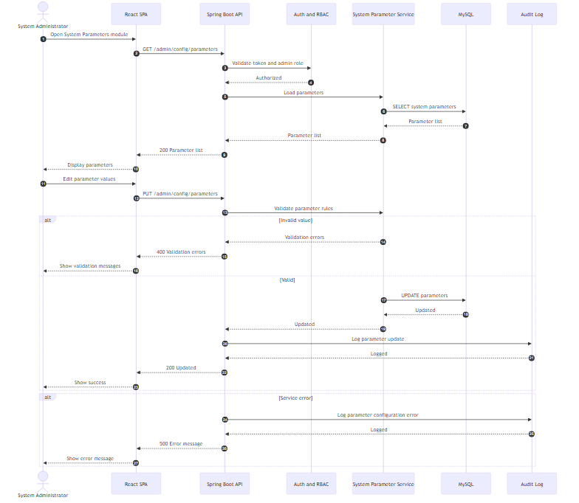

Report (numbered)
- Admin opens System Parameters module and loads current configuration values.
- System validates admin access and retrieves parameters from MySQL.
- Admin updates parameter values; system validates rules and constraints.
- If valid, parameters are updated and the action is logged; otherwise validation errors are displayed.
- Any service error is logged and shown.

4.2.32 UC32 Configure Integration and Export Settings (System Administrator)
FYP2 update: the use case is now split into two clearly separate sub-flows — (a) Integration Settings backed by integration_setting (with last_tested_at / last_test_result), and (b) Export Configurations backed by the new export_config table (reusable presets with optional schedule).
Figure 4.42 UC32 Configure Integration and Export Settings Sequence Diagram

Mermaid
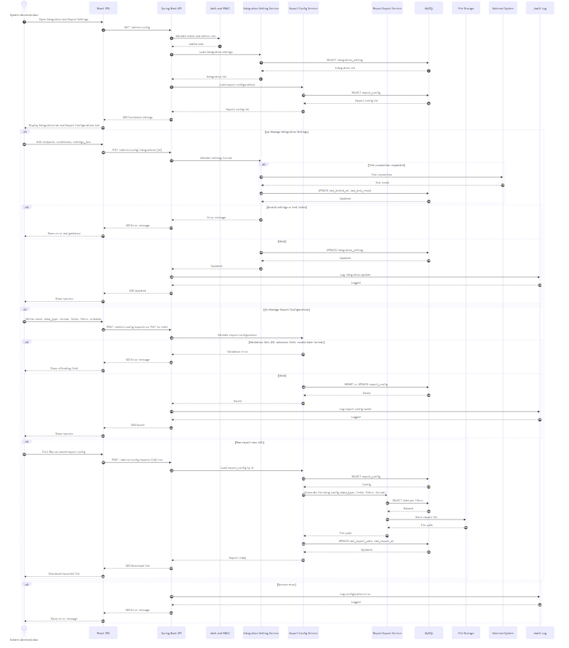

Report (numbered)
- Admin opens Integration and Export Settings module.
- System validates admin access and loads both integration_setting and export_config records from MySQL for the two tabs.
3. (a) Integration sub-flow — Admin updates endpoint and credentials; if a test connection is requested, the system calls the External System and stores last_tested_at and last_test_result. Valid settings are saved to integration_setting and audited.
4. (b) Export sub-flow — Admin defines or edits an export preset (data type, fields, filters, format, schedule). Valid presets are saved to export_config; invalid presets (e.g., unknown field, invalid date format) are rejected with a clear message (E2).
5. Admin can run a saved export preset on demand (A3); the system generates the file via the Report Export Service, stores it in File Storage, and updates last_export_path and last_export_at.
- Errors are logged and displayed.

4.2.33 UC33 Perform System Maintenance (System Administrator)
FYP2 update: every maintenance action is now wrapped with a maintenance_job record (status PENDING → RUNNING → COMPLETED / FAILED, plus triggered_by_user_id, result_json, timestamps) so the full job history is auditable. Added “View Job History” sub-flow.
Figure 4.43 UC33 Perform System Maintenance Sequence Diagram

Mermaid
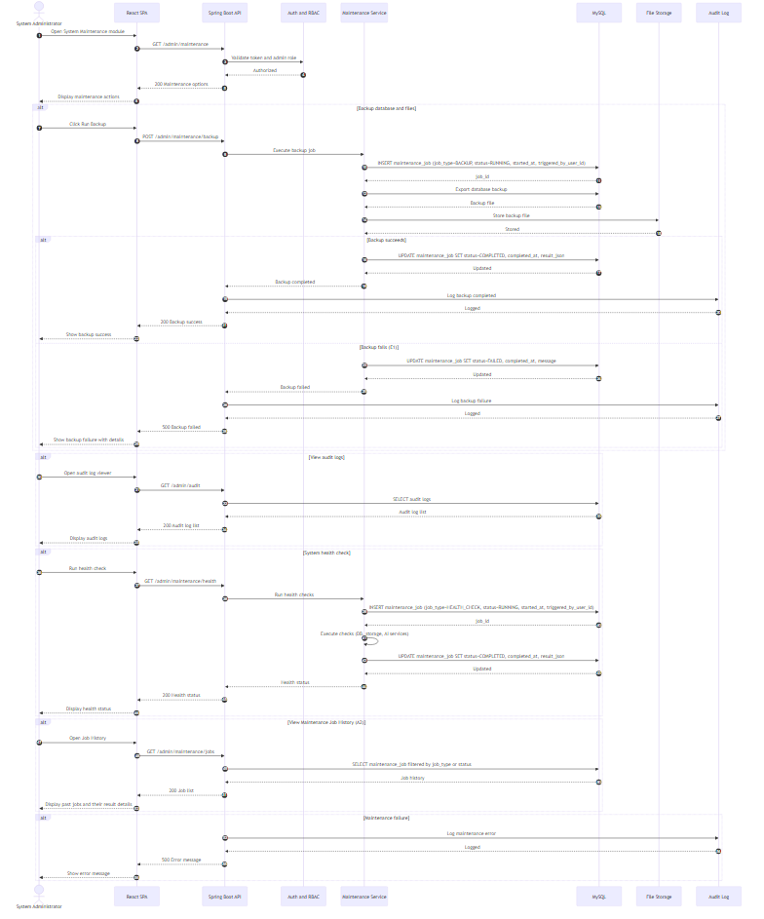

Report (numbered)
- Admin opens System Maintenance module and views maintenance actions.
2. For each maintenance action (backup, health check, cleanup), the system creates a maintenance_job record at start (status RUNNING, triggered_by_user_id, started_at).
- For backup, the system exports the database, stores the backup file, and logs completion.
4. The system finalises the maintenance_job record on completion or failure (status COMPLETED or FAILED, completed_at, result_json or message), giving a full audit trail.
- Admin may view audit logs, where the system retrieves audit entries from MySQL.
- Admin may run health checks, where the system returns health status results and stores the run as a maintenance_job for traceability.
7. Admin may open Maintenance Job History (A2) to filter past jobs by type or status and inspect their result details.
- Any maintenance failure is logged and displayed.

## 4.2.34 UC34 Track FYP1 Pass Outcome (System Administrator)
FYP2 addition: new use case introduced during FYP2 implementation to record the externally-produced FYP1 pass/fail decision and to surface the meeting-log compliance count as a non-blocking soft warning at decision time.
Figure 4.44 UC34 Track FYP1 Pass Outcome Sequence Diagram

Mermaid
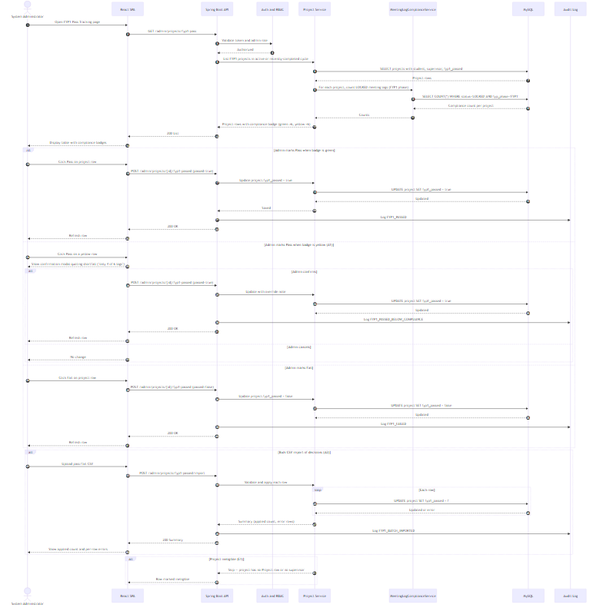

Report (numbered)
- System Administrator opens the FYP1 Pass Tracking page.
- Backend validates admin access and asks Project Service for every FYP1 project in the relevant cycle.
- For each project, MeetingLogComplianceService counts the LOCKED meeting logs in the FYP1 phase; the result is rendered as a coloured badge (green ≥ 6, yellow < 6).
- Admin clicks Pass or Fail per row; system updates Project.fyp1_passed and audit-records the decision.
- If the badge is yellow when the admin marks Pass (A1), the system shows a confirmation modal quoting the shortfall before proceeding. The action is recorded as FYP1_PASSED_BELOW_COMPLIANCE in the audit log.
- Alternatively (A2), the admin uploads a CSV of decisions for batch processing; the system validates each row, applies the outcomes, and returns a per-row summary.
- Projects without a supervisor or without a Project row are skipped (E1) and reported back to the admin.

## 4.2.35 UC35 Grade Final Report (Supervisor + System Administrator + Student)
FYP2 addition: new use case introduced during FYP2 implementation. The grader (assigned supervisor) submits a JSON-based rubric that flows through DRAFT → SUBMITTED → FINALISED; only FINALISED grades reach the student.
Figure 4.45 UC35 Grade Final Report Sequence Diagram

Mermaid
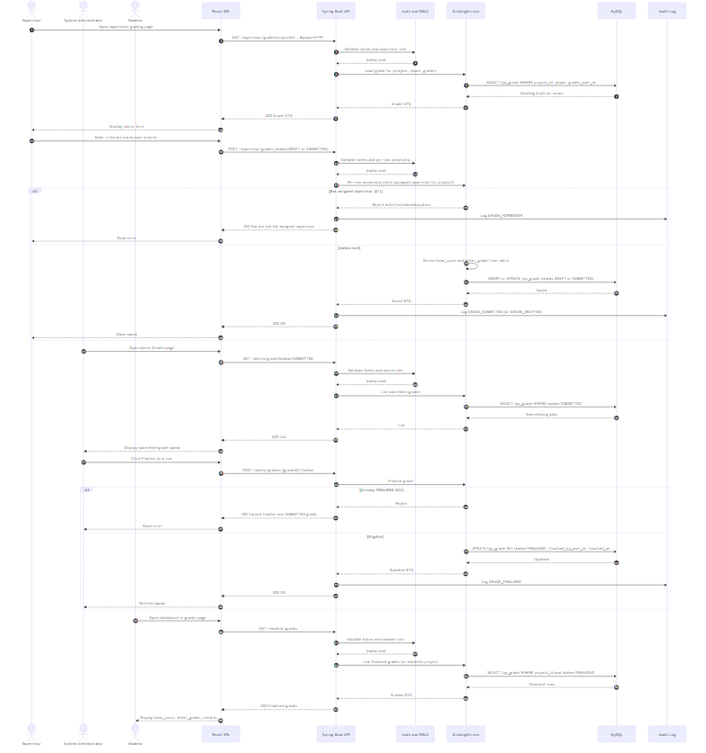

Report (numbered)
- Supervisor opens the supervisee grading page.
- System validates token and looks up any existing draft grade for (project, phase, grader).
- Supervisor fills in the criterion marks and optional remarks; system derives total_score (sum) and letter_grade (MMU FCI scale).
- Per-row ownership check confirms the grader is the assigned supervisor for the project; if not (E1), ForbiddenException is returned and the action is audit-logged as GRADE_FORBIDDEN.
- Otherwise the grade row is upserted in fyp_grade with status DRAFT or SUBMITTED, audit-logged accordingly.
- System Administrator opens the Admin Grades page, sees the SUBMITTED queue, and clicks Finalise on a row.
- If the grade is already FINALISED (E2) the action is rejected; otherwise status flips to FINALISED and finalised_by_user_id/finalised_at are recorded. The action is audit-logged as GRADE_FINALISED.
- Student opens their dashboard; system returns only FINALISED grades for the student’s project, with total score, letter grade and remarks.

## 4.2.36 UC36 Manage FYP Cycle Lifecycle (System Administrator)
FYP2 addition: new use case introduced during FYP2 implementation. CycleLifecycleService enforces the “at most one ACTIVE cycle per cycle_type” invariant and runs the automatic side-effects (placeholder backfill on activation, notification fan-out on completion, FYP1 → FYP2 promotion on next login).
Figure 4.46 UC36 Manage FYP Cycle Lifecycle Sequence Diagram

Mermaid
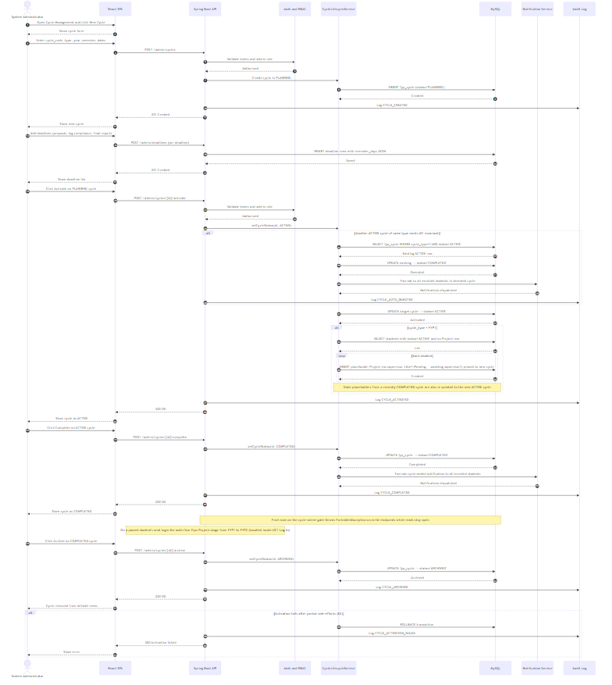

Report (numbered)
- Admin creates a new cycle (type, year, semester, dates); status starts as PLANNING.
- Admin attaches per-cycle deadlines, each with reminder days encoded as JSON.
- Admin activates the cycle. If another cycle of the same type is already ACTIVE, CycleLifecycleService demotes it to COMPLETED first and fans out notifications to all enrolled students (invariant E1).
- For FYP1 cycle activation, backfillFyp1Placeholders runs: every active student without a Project row gets a placeholder one pinned to the new cycle. Stale placeholders from the previous cycle are re-pointed to the new ACTIVE cycle (A1).
- Cycle runs through the trimester. All student write endpoints work as normal.
- Admin marks the cycle as COMPLETED. Notifications fan out to every enrolled student. From this point, StudentAccessService.requireActiveCycle throws ForbiddenException on write endpoints, while reads remain open.
- For passed students, AuthService.refreshFyp1Status flips Project.stage from FYP1 to FYP2 on their next login when both prerequisites are met (A2; the flip is part of UC1 Log In).
- Admin archives the cycle once the academic year closes; the cycle drops off default views but remains as a historical record.
- If activation fails after partial side-effects (E2), the system rolls back, audit-logs the failure, and surfaces the error to the admin.

